About the Chapter
BMSCE IEEE Women in Engineering (WIE) is a vibrant community dedicated to empowering students through technical learning, leadership, innovation, collaboration, and community engagement. Through workshops, hackathons, competitions, panel discussions, awareness initiatives, and collaborative events, WIE provides students with opportunities to explore technology, develop real-world skills, and grow beyond the classroom.

Our Past Events
- Eco-Bid – A strategy-based environmental debate conducted in collaboration with IEEE SSIT as part of IMPACT 1.0.
- Fire Safety, Chemical Safety & BLS Training – A practical safety and emergency-response training initiative conducted with IQAC and the Department of Chemistry.
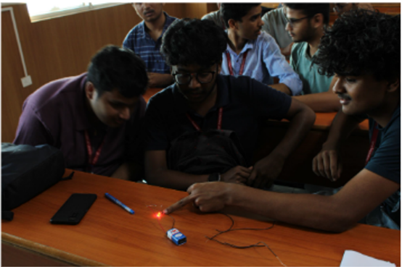
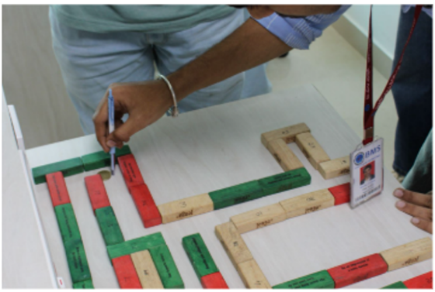
- Spark Grid – An engaging PES Day event combining precision challenges with sensor-based activities.
- Mind Market: Decode, Trade & Dominate – A strategy competition combining fault-finding, communication, and resource trading.
- Walkathon – A 5 km community initiative promoting women’s leadership, wellness, and awareness.
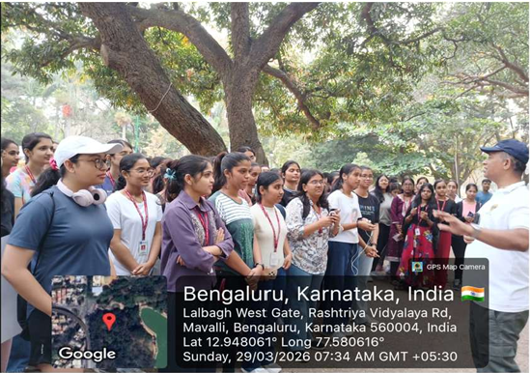
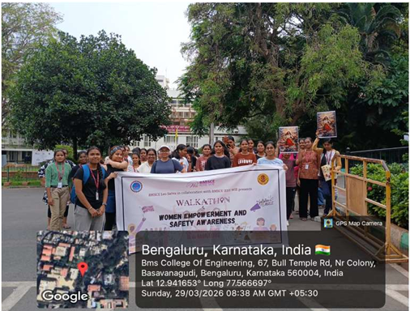
- Menstrual Wellness & Sustainable Products – An awareness initiative exploring menstrual health and sustainable menstrual products.
- Cyber Talk – An introductory session exploring cybersecurity and its growing relevance in the technology landscape.
- WIE Day 2026 – A multi-event celebration featuring technical, creative, scientific, cybersecurity, AI, web development, and awareness-focused initiatives.

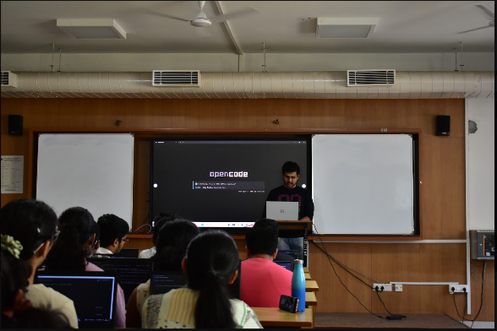
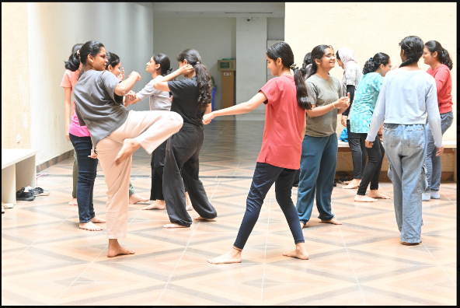
Flagship Events
- WIE DAY
Our flagship annual celebration featuring a diverse range of technical, creative, scientific, and awareness-driven events through collaborations with IEEE chapters and student organizations.
- NEXUS
A two-day technical summit featuring workshops, panel discussions, startup competitions, and hackathons.
- DATAVERSE
An 8-hour data hackathon where participants use analytics, data science, and machine learning to solve real-world problems.
- STARTOPOLIS
A startup-focused initiative that encourages students to explore, develop, and present innovative ideas.

Upcoming Events
- BrainRush 3.0 – A fun, game-based challenge built around quick thinking, strategy, and teamwork.
- Game Development Event – An interactive session introducing students to the world of game development.
- AR/VR Session – An introduction to immersive technologies and their applications.
- Cybersecurity Workshop – A practical introduction to cybersecurity concepts and emerging technologies.
- Outreach Initiative – A community-focused initiative aimed at creating meaningful social impact.

